Паттерны PageObjects и StepObjects

Структура проекта с использованием паттернов
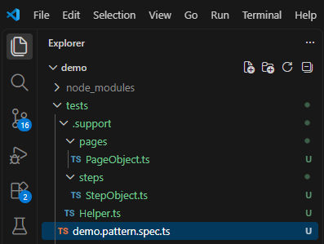
Файл: \tests\.support\Helper.ts

export class Helper {
static readonly URL = 'https://somovstudio.github.io/test.html';
static readonly USERNAME = 'admin';
static readonly PASSWORD = '0000';
}
Файл: \tests\.support\pages\PageObject.ts

export class PageObject {
static readonly FORM_LOGIN = "#login";
static readonly FORM_PASS = "#pass";
static readonly FORM_BUTTON_LOGIN = "#buttonLogin";
static readonly POPUP_RESULT = "#result";
static readonly POPUP_TEXTAREA = "#textarea";
}
Файл: \tests\.support\steps\StepObject.ts

import { Page, expect, test, Browser } from '@playwright/test';
import { PageObject } from '../pages/PageObject';
import { Helper } from '../Helper';

export class StepObject {
static async sendForm(page: Page): Promise<void> {
await page.locator(PageObject.FORM_LOGIN).fill(Helper.USERNAME);
await page.locator(PageObject.FORM_PASS).fill(Helper.PASSWORD);
await page.locator(PageObject.FORM_BUTTON_LOGIN).click();
}
}

Файл: \tests\demo.pattern.spec.ts

import { test, expect } from '@playwright/test';
import { StepObject } from './.support/steps/StepObject';
import { PageObject } from './.support/pages/PageObject';
import { Helper } from './.support/Helper';

test('Авторизация', async ({ page }) => {
await page.goto(Helper.URL);
await expect(page).toHaveTitle('Тестовая страница');
StepObject.sendForm(page);
await expect(page.locator(PageObject.POPUP_RESULT)).toBeVisible();
await expect(page.locator(PageObject.POPUP_TEXTAREA))
.toHaveValue('Вы успешно авторизованы');
});

